**Model Development Phase Report**

|  |  |
| --- | --- |
| Date | 12 July 2024 |
| Team ID | Team - 740292 |
| Project Title | Abalone Age Prediction |
| Maximum Marks | 4 Marks |

**Initial Model Training Code, Model Validation and Evaluation Report**

The initial model training code will be showcased in the future through a screenshot. The model validation and evaluation report will include Model Training and accuracy score, presented through respective screenshots.

**Initial Model Training Code:**

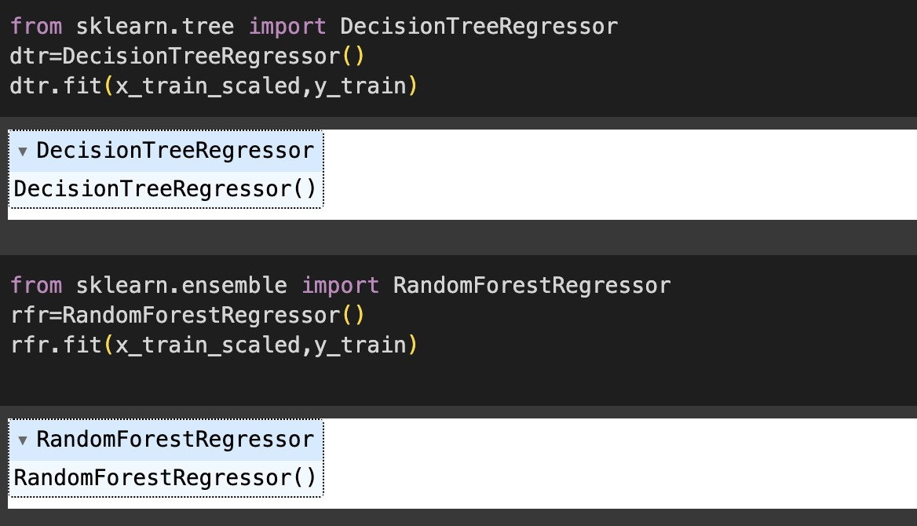

**Model Validation and Evaluation Report:**

|  |  |  |
| --- | --- | --- |
|  |  | **Accuracy Score** |
| **Model** | **Accuracy Report** |  |
| Decision  Tree  Regressor |  | 100% |

|  |  |  |
| --- | --- | --- |
| Random  Forest  Regressor |  | 93% |